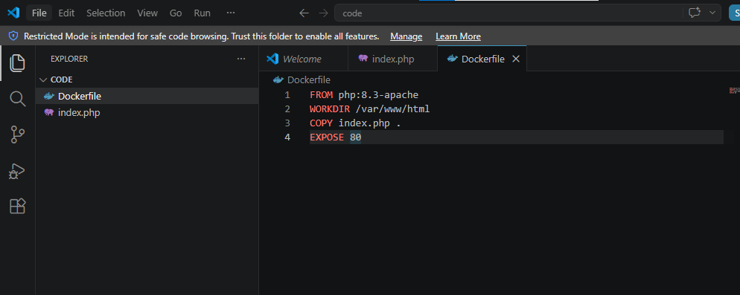

FROM php:8.3-apache
WORKDIR /var/www/html
COPY index.php .
EXPOSE 80

<!DOCTYPE html>
<html>
<head>
<title>My PHP Website</title>
</head>
<body>
<h1>Welcome to My PHP Website</h1>

<p>
<?php
echo "Hello! This page is created using PHP.";
?>
</p>

<hr>

<a href="index.php">Home</a> |
<a href="about.php">About</a> |
<a href="contact.php">Contact</a>
</body>
</html>

Step 1: Verify Docker is installed
docker --version

Step 2: Check your Docker images
docker images
Example output:
REPOSITORY TAG IMAGE ID
php-website latest abcd12345678

Step 3: Create a Docker Hub account
If you don't already have one, create an account at https://hub.docker.com.
Suppose your Docker Hub username is:
john123

Step 4: Log in to Docker Hub
On your Azure VM, run:
docker login
Enter:
- Docker Hub Username
- Docker Hub Password (or Personal Access Token if you use one)
If successful, you'll see:
Login Succeeded

Step 5: Tag the Docker image
Docker Hub images must be tagged with your Docker Hub username.
Syntax:
docker tag <local-image-name>:<tag> <dockerhub-username>/<repository-name>:<tag>
Example:
docker tag php-website:latest john123/php-website:latest
Check the images again:
docker images
You should now see something like:
REPOSITORY TAG
php-website latest
john123/php-website latest

Step 6: Push the image
docker push john123/php-website:latest
Docker will upload the image layers to Docker Hub.

Step 7: Verify on Docker Hub
Log in to Docker Hub in your browser.
Open Repositories.
You should see:
php-website

On the AWS EC2 Instance

Step 8: Install Docker
sudo apt update
sudo apt install docker.io -y
sudo systemctl enable docker
sudo systemctl start docker
sudo usermod -aG docker $USER
newgrp docker

Step 9: Log in to Docker Hub
docker login

Step 10: Pull the image
docker pull john123/php-website:latest

Step 11: Run the container
docker run -d -p 80:80 --name php-app john123/php-website:latest

Step 12: Verify
Open your browser:
http://<AWS-EC2-Public-IP>
You should see your PHP website running on AWS.

